

**MCTE 4352**

**ROBOTICS**

**SECTION 1**

**SEM I || SESSION 20/21**

|  |  |
| --- | --- |
| **NAMES** | **MATRIC NO.** |
| **MUHAMMAD AZEEM BIN ROSLI** | **1710689** |

|  |  |
| --- | --- |
| **DATE OF SUBMISSION**  **19 DECEMBER 2020** | **TOTAL MARKS** |

**1.0 OBJECTIVES**

1. To simulate SCARA Robot by using Matlab
2. To compare path created by the Robotics Toolbox in Matlab and line graph created by the Excel
3. To simulate motion of 2D and 3D planar of a SCARA Robot

**2.0 PROCEDURE**

1. Get x- and y- coordinates of ellipse by using angles in radians, $x=100\cos{θ}, y=150sinθ+350$
2. First, in Matlab, set the z-coordinates to be constant, then observe and compare with Excel result
3. Next, in Matlab, set the z-coordinates to be varied, then observe and compare with Excel result

**3.0 RESULTS**

**Table of Data**

|  |  |  |  |
| --- | --- | --- | --- |
| **θ** | **100cosθ** | **150sinθ+350** | **Z-cord** |
| **0** | **100** | **350** | **0** |
| **36** | **80.9017** | **438.1678** | **-14** |
| **72** | **30.9017** | **492.6585** | **-28** |
| **108** | **-30.9017** | **492.6585** | **-42** |
| **144** | **-80.9017** | **438.1678** | **-56** |
| **180** | **-100** | **350** | **-70** |
| **216** | **-80.9017** | **261.8322** | **-84** |
| **252** | **-30.9017** | **207.3415** | **-98** |
| **288** | **30.9017** | **207.3415** | **-112** |
| **324** | **80.9017** | **261.8322** | **-126** |
| **360** | **100** | **350** | **-140** |

**Generated Motion Path Graph.**

Figure 1 Ellipse Line Graph, 2D Planar

**DH Frame Assignments**

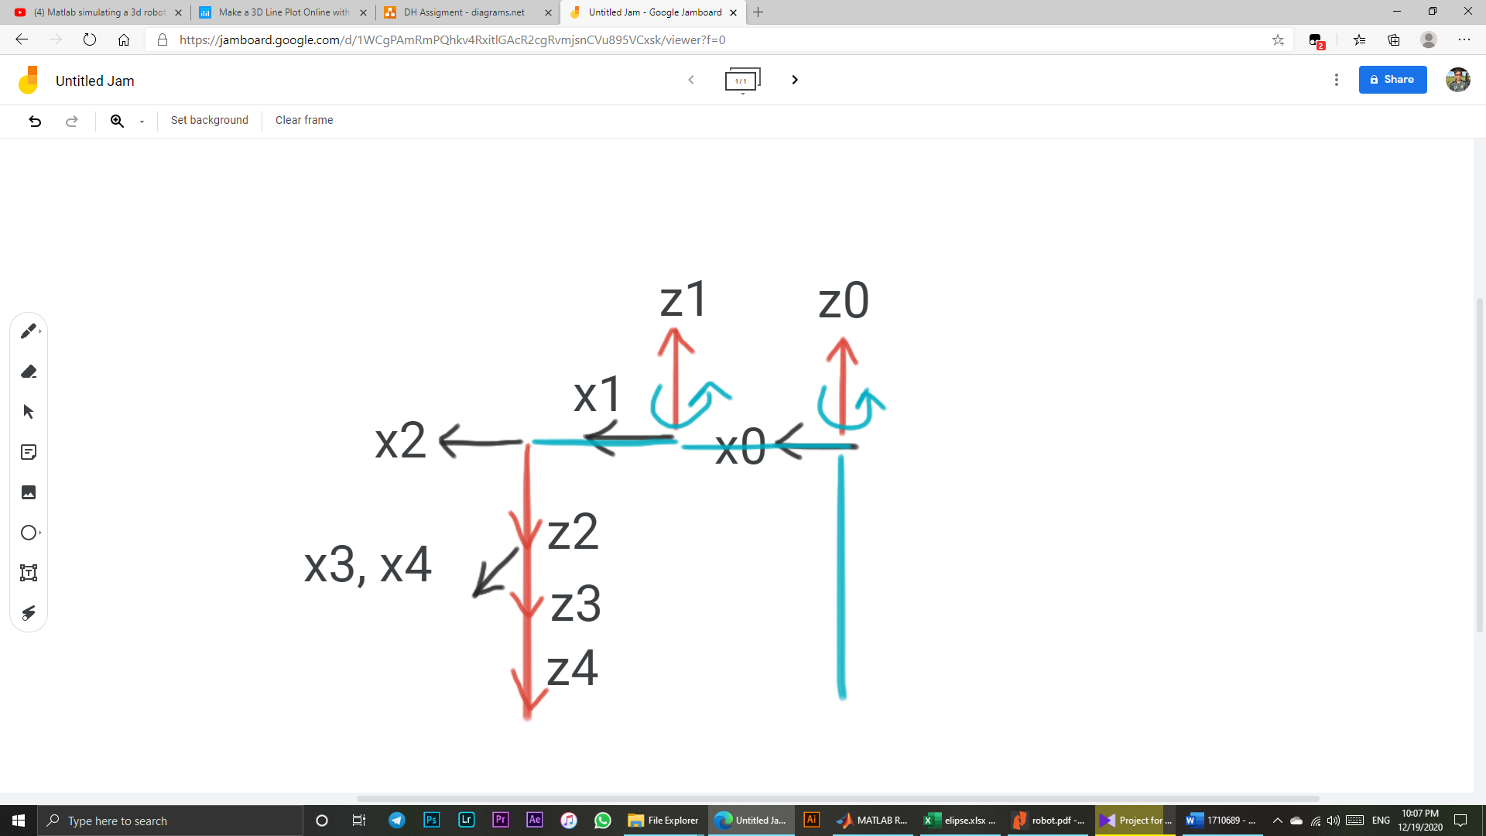

Figure 2 DH Assignment

**DH Parameters Table**

|  |  |  |  |  |
| --- | --- | --- | --- | --- |
| Joint | θ | d | a | α |
| 0-1 | θ1 | 0 | 325 | 0 |
| 1-2 | θ2 | 0 | 225 | 180 |
| 2-3 | -90 | d3 | 0 | 0 |
| 3-4 | θ4 = 0 | 0 | 0 | 0 |

1. **ROBOTICS TOOLBOX – MATLAB**

**Coding Matlab:**

L1 = 325;

L2 = 225;

L(1) = Link([0 0 L1 0 0]);

L(2) = Link([0 0 L2 pi 0]);

L(3) = Link([-pi/4 0 0 0 1]);

% set limits for joints

L(1).qlim=[deg2rad(-170) deg2rad(170)];

L(2).qlim=[deg2rad(-150) deg2rad(150)];

L(3).qlim=[0 140];

Scara = SerialLink(L, 'name', 'Scara');

input_data = readmatrix(‘ellipse.xlsx');

X = input_data(:,2:2);

Y = input_data(:,3:3);

Z = input_data(:,4:4);

for i = 1:(length(X)-1)

T(:,:,i) = transl(X(i), Y(i), Z(i));

% T(:,:,i) = transl(X(i), Y(i), 0);

end

qs = Scara.ikcon(T);

Scara.plot(qs,'loop','trail', {'r', 'LineWidth', 2});

**SCARA Simulation Matlab:**

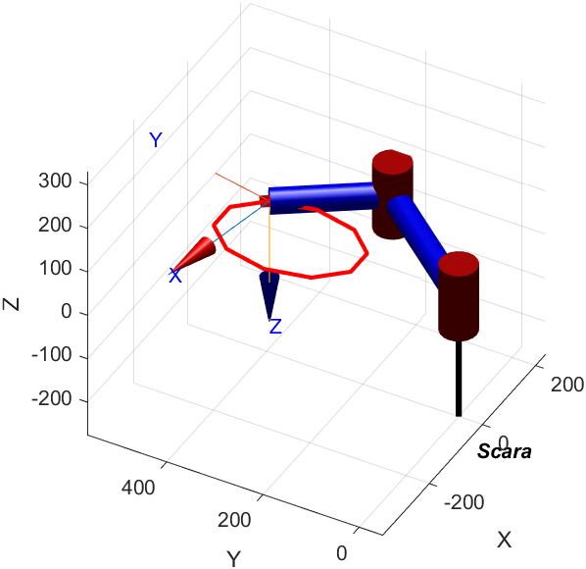

Figure 3 2D Planar Motion

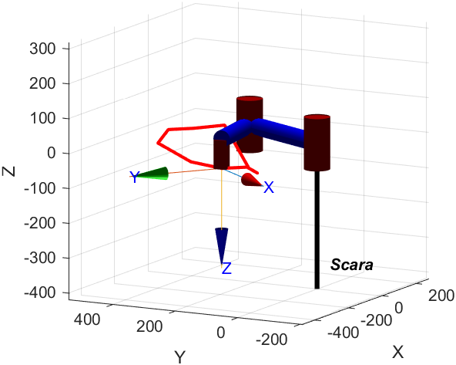

Figure 4 3D Planar Motion

1. **DISCUSSION**

The coordinates of ellipse are determined by inserting angles in radians into $x=100\cos{θ}, y=150sinθ+350$. The z-coordinates is constant and in the next experiment, the z-coordinates is varied from 0 to 140 with a step of -14.

For the first experiment, the path of motion in SCARA Robot simulated by using Robotics Toolbox in Matlab is similar with the path of line graph created in Excel. For the second experiment, the ellipse is slanted, however it is unsmoothed due to the huge step of the z-motion. The path also is further than the 2D planar motion.